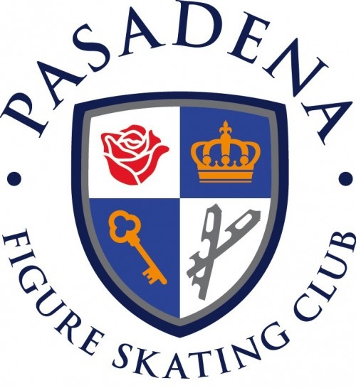
Pasadena Figure Skating Club
2016 Valentine Show

“Love is in the Air”

Sunday, February 14th 2016
7 - 9 pm

Pasadena Figure Skating Club’s Junior Board proudly presents this year’s Valentine’s Day Show, “Love is in the Air”. The theme is not strictly enforced, so feel free to let your creativity run wild. There will be one mandatory dress rehearsal on Friday, February 12th from 5:30-6:30.

There are a limited number of performances for solos, groups and duets. Each application will be accepted on a first-come, first-serve basis. Applications that are mailed will be accepted by the post-mark date.

Entry deadline: January 9th, 2016

General Rules:
- Applications for solos, duets and groups must be filed separately.
- All entries are accepted on a first-come, first-serve basis.
- No refunds after January 25, 2016
- Each skater can only participate in a maximum of 3 events.
- Skaters are financially responsible for their own music, costumes, ice time, props, coaches, and choreographers.
- Props may be used, but they must be easily moved on and off the ice by the skaters.
- Applications with missing contact information will be rejected.
- Dress rehearsal is mandatory.
- HAVE FUN!

Maximum Performance Times (there is no minimum):
Solo:
All ISI Levels | 1:30 minutes
Pre-preliminary – Juvenile | 2:00 minutes
Intermediate – Senior | 2:45 minutes

Duets/Trios/Groups
ISI levels - Juvenile | 2:00 minutes
Intermediate - Senior | 3:00 minutes

Mail applications to:
Stacey Yee
6929 Ferncroft Ave,
San Gabriel, CA, 91775
Digital Copies to:
s.tee.yee@gmail.com

If you have any further questions, please don’t hesitate to contact PFSC Junior Board President:

Stacey Yee
s.tee.yee@gmail.com

Make check(s) or money order(s) payable to Pasadena Figure Skating Club. There will be a $25.00 charge for returned checks. Send check and entry form to PFSC Junior Board President, Stacey Yee, by the application deadline January 16, 2016.

Solo Entry Form

Name:____________________________________ Age: _______ Gender: M / F
Parent’s Name:_____________________________ Membership #: _______________
E-Mail:____________________________________ Tele (cell / house): ____________
Best time to contact (circle one): Morning Afternoon Evening
Music
Skater’s Level:__________________________
Music Choice: __________________________ Artist: __________________________
Duration: min. sec.
Entry Fees
Events | Fees
Solo (Club members) | $35
Non-club member | $40

Total Fees: $ _________
Please write some information (such as recent achievements, why you chose your music, or to whom you would like to dedicate it) on the lines below if you would like the announcer to use this information as an introduction before your performance. Use the back of the page if necessary.
_______________________________________________________________________________________________________________________________________________________________________________________________________________________________________________________________________________________
I am aware that skaters skate at their own risk, and I release the Pasadena Figure Skating Club, the Pasadena Ice Skating Center, and the representatives of both from any liability with regard to my participation in this show. I also understand that all final decisions regarding the show are to be made by the show directors, and I agree to abide by the decisions set forth.
____________________________________ ____________________________
signature of participant date signature of parent/legal guardian date
Duets, Trios, and Group Entry Form

Only one application form needed per duet or group number.

Duets/Trios
Names: _____________________________and_______________________________
and___________________________
PFSC Membership #s:_______________and _________________and _____________
Main Contact: ___________________ Email: _________________________________
Tel: __________________________________ or ______________________________
Best time to contact (circle one): Morning Afternoon Evening

Group Number (4 - 8 people)
Names of Skaters:

__________________________________ __________________________________
1st participant Membership # 2nd participant Membership #

__________________________________ __________________________________
3rd participant Membership # 4th participant Membership #

__________________________________ __________________________________
5th participant Membership # 6th participant Membership #

__________________________________ __________________________________
7th participant Membership # 8th participant Membership #

Group’s Main Contact: ___________________ Email: __________________________
Tel: __________________________________ or ______________________________
Best time to contact (circle one): Morning Afternoon Evening

Pg. 1
Music
Lowest Skater’s Level:____________________
Music Choice: __________________________ Artist: __________________________
Duration: min. sec.

Entry Fees
Events | # of skaters | Fees | Total
Duets and Trios | 2 / 3 | $25/person (club members)
Duets and Trios | 2 / 3 | $30/person (non club members)
Group Number |  | $15/person (club members)
Group Number |  | $20 /person (non club members)

Total Fees: $ ____________
Please write some information (such as recent achievements, why you chose your music, or to whom you would like to dedicate it) on the lines below if you would like the announcer to use this information as an introduction before your performance. Use the back of the page if necessary.
_________________________________________________________________________________________________________________________________________________________________________________________________________________________________________________________________________________________________________________________________________________________________________________________________________________________________________________________________________________
I am aware that skaters skate at their own risk, and I release the Pasadena Figure Skating Club, the Pasadena Ice Skating Center, and the representatives of both from any liability with regard to my participation in this show. I also understand that all final decisions regarding the show are to be made by the show directors, and I agree to abide by the decisions set forth.

Pg. 2
___________________________________________________ _______________________________________
signature of 1st participant date signature of parent/legal guardian date

___________________________________________________ _______________________________________
signature of 2nd participant date signature of parent/legal guardian date

___________________________________________________ _______________________________________
signature of 3rd participant date signature of parent/legal guardian date

___________________________________________________ _______________________________________
signature of 4th participant date signature of parent/legal guardian date

___________________________________________________ _______________________________________
signature of 5th participant date signature of parent/legal guardian date

___________________________________________________ _______________________________________
signature of 6th participant date signature of parent/legal guardian date

___________________________________________________ _______________________________________
signature of 7th participant date signature of parent/legal guardian date

___________________________________________________ _______________________________________
signature of 8th participant date signature of parent/legal guardian date

Pg. 3

